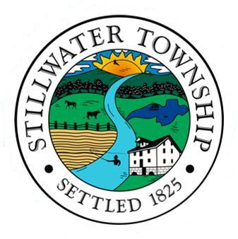
Stillwater Garage Sale Weekend
Lets’ Beat the Heat with a Cooler Date!
May 18th & 19th 2024
Rain or Shine
The Recreation Commission is holding a second Garage Sale Weekend at the request of the residents of Stillwater Township. Please fill out and return this application by Friday, May 3rd, and your location will be listed on the town-wide garage sale map.

Those registering for the garage sale should be specific when listing their sale items. Listing “household and clothing” doesn’t cut it for shoppers, most are looking for certain items!

REGISTRATION FEE IS $5.00 for residents. PLEASE KEEP IN MIND YOUR APPLICATION MUST BE RECEIVED BY May 3rd TO BE INCLUDED ON THE TOWN-WIDE GARAGE SALE MAP.

Maps will be available at Town Hall during normal business hours starting on Monday, May 13th, on the Stillwater Township website.

Stillwater Township is committed to protecting the health and safety of our community and complies with Public Health guidelines.
PLEASE RETURN THIS FORM NO LATER THAN MAY 3rd.
Name: ______________________________________________________________________
Address:____________________________________________________________________
___________________________________________________________________________
Home/Business Phone:_____________________ Cell:_____________________________
E-Mail Address:______________________________________________________________
Sale Items:__________________________________________________________________
___________________________________________________________________________
❒ ALL WEEKEND  SATURDAY ONLY  SUNDAY ONLY

RETURN APPLICATION TO: Stillwater Township
964 Stillwater Road • Newton, NJ 07860

OR EMAIL APPLICATION TO: recreation@stillwatertwp.com

REGISTRATION FEE IS $5.00 FOR RESIDENTS - NO REFUNDS
Would you be interested in participating in a FALL Garage Sale Weekend in October? REGISTRATION FEE IS $5.00 FOR RESIDENTS.

YES, I WOULD BE INTERESTED ____________ NO INTEREST____________

