STILLWATER TOWNSHIP ZONING BOARD OF ADJUSTMENT
October 23, 2023

A REGULAR MEETING of the Stillwater Township Zoning Board of Adjustment was held on the above date and time. The meeting was called to order by Chairman Lippencott in accordance with the Open Public Meetings Act. The flag was saluted, and roll call taken:

MEMBERS PRESENT: Mr. Lippencott, Mr. Wykoff, Mrs. Mountford, Mr. Doolittle

MEMBERS ABSENT: Mrs. Draghi, Mr. Kochenthal and Mr. van der Haeghen

ALSO PRESENT: Matthew Lynch, Esq. {on behalf of William Haggerty, Esq.) and Committee Liaison, Dawn Delaney

SWEARING IN OF BOARD MEMEBERS: None

MINUTES:

Mrs. Mountford made the motion to approve the minutes of September 25, 2023, seconded by Mr. Doolittle.

Roll Call vote in favor:
Mrs. Mountford - Yes, Mr. Doolittle - Yes, Mr. Lippencott - Yes, Mr. Wykoff- Yes

RESOLUTIONS: None

COIVIPLET_ENl;SS: #23-004 Armenante - 941 Emmons Lane, Block 3603, Lot 23

Testimony was given by Engineer, Joe Vuich confirming that the application was complete, and the matter may move forward for a hearing.

HEARINGS: #23-004 Armenante - 941 Emmons Lane, Block 3603, Lot 23

This matter was presented by the Applicant's attorney, David Brady, Esq. The applicant purchased the property in 2019. She hired a contractor to add a second story. As the job progressed, the home was found to be in worse condition than expected. When inspected by the Zoning Officer it was determined that more than 50% of the home had been removed. The building's footprint was also increased slightly to adjust the foundation requirements. The applicant was then required to resubmit her application to the Board for a Bulk Variance. The hearing was delayed for various reasons including, covid, etc.

Alison Kopsco of J. Caldwell and Associates also gave testimony on behalf of the applicant. She provided an overlay of the existing structure in comparison to the proposed structure outlining the minimal changes and explained that the improvements would benefit the property and not create any substantial detriment.

The hearing was opened to the public. With there being no public comment, the hearing was closed to the public.

Mrs. Mountford made the motion to accept the application for side yard and rear yard setbacks, seconded by Mr. Wykoff.

Roll Call vote in favor:
Mrs._Mountford - Yes, Mr. Wykoff- Yes, Mr. Lippencott- Yes, Mr. Doolittle - Yes

BILLS: None

CORRESPONDENCE: None

OLD/NEW BUSSINESS: The current 2023 Budget was presented, and discussion was held regarding the proposed 2024 Budget.

Mr. Wykoff made the motion to utilize the same numbers for the 2024 Budget that were used in the 2023 Budget, seconded by Mrs. Mountford.

Roll Call vote in favor:
Mr. Wykoff- Yes, Mrs. Mountford - Yes, Mr. Lippencott- Yes, Mr. Doolittle - Yes

EXECUTIVE SESSION: None

OPEN TO THE PUBLIC: The session was opened to the public at 8:25 pm. There being no public comment, the session was closed to the public.

COMMITTEE LIAISON REPORT: Committee Liaison report was provided to the Board by Committeewoman, Dawn Delaney.

ADJOURNMENT: With there being no further business, at 8:29pm a motion was made to adjourn the meeting. With a voice vote, all were in favor.

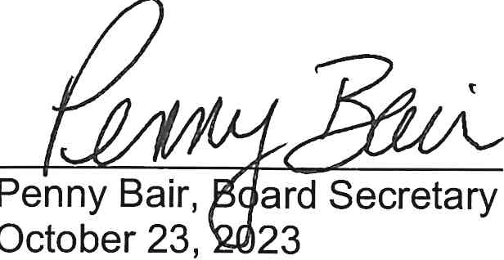
Respectfully submitted,

