STILLWATER TOWNSHIP ZONING BOARD OF ADJUSTMENT
November 20, 2023

A REGULAR MEETING of the Stillwater Township Zoning Board of Adjustment was held on the above date and time. The meeting was called to order by Kathy Draghi in accordance with the Open Public Meetings Act. The flag was saluted, and roll call taken:

MEMBERS PRESENT: Mrs. Draghi, Mrs. Mountford, Mr. van der Haeghen, Mr. Kochenthal, Mr. Doolittle

MEMBERS ABSENT: Mr. Lippencott and Mr. Wykoff

ALSO PRESENT: William Haggerty, Esq. and Committee Liaison, Dawn Delaney

SWEARING IN OF BOARD MEMEBERS: None

A motion was made by Mr. van der Haeghen to appoint Mrs. Draghi as acting Chairperson, seconded by Mr. Kochenthal.

Roll Call vote in favor:
Mr. van der Haeghen - Yes, Mr. Kochenthal - Yes, Mrs. Draghi - Yes, Mrs. Mountford
- Yes, Mr. Doolittle - Yes

MINUTES:

Mrs. Mountford made the motion to approve the minutes of October 23, 2023, seconded by Mr. Doolittle.

Roll Call vote in favor:
Mrs. Mountford - Yes, Mr. Doolittle - Yes, Mrs. Draghi - Abstained, Mr. van der Haeghen -Abstained, Mr. Kochenthal -Abstained

Minutes will be carried to the December meeting for approval.

RESOLUTIONS: Armenante, Block 3603, Lot 23

Mrs. Mountford made the motion to memorialize the above Resolution, seconded by Mr. Doolittle.

Roll Call vote in favor:
Mrs. Mountford - Yes, Mr. Doolittle - Yes, Mrs. Draghi -Abstained, Mr. van der Haeghen - Abstained, Mr. Kochenthal - Abstained

COMPLETENESS: None

HEARINGS: None

BILLS:

Mr. Doolittle made the motion to pay the following bills, seconded by Mr. van der Haeghen.

Dolan & Dolan - | General | $359.65
Dolan & Dolan - | Zelinsky, Block 203, Lot 30 | $ 59.50
Dolan & Dolan - | Maio, Block 305, Lot 17 | $ 66.00
Dolan & Dolan - | Armenante, Block 3603, Lot 23 | $ 76.50

Alternative Business Services, Inc. (name plate for Mr. Doolittle) NJPO - Training for Mr. Doolittle and P. Bair
$ 16.00
$178.50

Roll Call vote in favor:
Mr. Doolittle - Yes, Mr. van der Haeghen - Yes, Mrs. Draghi - Yes, Mrs. Mountford - Yes, Mr. Kochenthal - Yes

CORRESPONDENCE: NJ Planner

OLD/NEW BUSSINESS: None

EXECUTIVE SESSION: None

OPEN TO THE PUBLIC: The session was opened to the public at 7:35pm. There being no public comment, the session was closed to the public.

COMMITTEE LIAISON REPORT: Committee Liaison report was provided to the Board by Committeewoman, Dawn Delaney.

ADJOURNMENT: With there being no further business, at 7:38pm a motion was made to adjourn the meeting. With a voice vote, all were in favor.

Respectfully submitted,
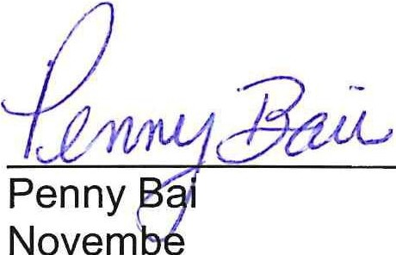

r, Board Secretary r 20, 2023

