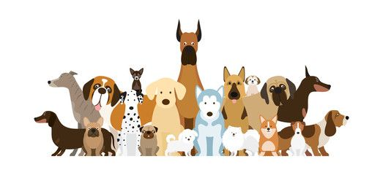
2023 Dog License Application Stillwater Township 964 Stillwater Road, Newton, NJ 07860
No applications are accepted before January 1, 2023
Rabies Vaccination Must be Valid after
November 1, 2023 to issue License
Fees: Spayed/Neutered $ 11.00, Non-Spayed/Neutered $ 14.00 Late Fee Charged: $ 5.00 PER MONTH PER DOG after January 31, 2023

Owner’s Name: ________________________________________________ Phone: ________________________
DOGS NAME: _______________________ BREED:_______________________ COLOR:__________________

HAIR: Long Medium Short AGE: _________ GENDER: Male Female

Rabies Expiration (must be Valid after 11/1/2023 Attach Proof of Vaccine Expiration): _______________

Spayed/Neutered: YES NO Please provide Spay/Neuter Certificate for first time licensing
DOGS NAME: _______________________ BREED:_______________________ COLOR:__________________

HAIR: Long Medium Short AGE: _________ GENDER: Male Female

Rabies Expiration (must be Valid after 11/1/2023 Attach Proof of Vaccine Expiration): _______________

Spayed/Neutered: YES NO Please provide Spay/Neuter Certificate for first time licensing
DOGS NAME: _______________________ BREED:_______________________ COLOR:__________________

HAIR: Long Medium Short AGE: _________ GENDER: Male Female

Rabies Expiration (must be Valid after 11/1/2023 Attach Proof of Vaccine Expiration): _______________

Spayed/Neutered: YES NO Please provide Spay/Neuter Certificate for first time licensing
DOGS NAME: _______________________ BREED:_______________________ COLOR:__________________

HAIR: Long Medium Short AGE: _________ GENDER: Male Female

Rabies Expiration (must be Valid after 11/1/2023 Attach Proof of Vaccine Expiration): _______________

Spayed/Neutered: YES NO Please provide Spay/Neuter Certificate for first time licensing
DOGS NAME: _______________________ BREED:_______________________ COLOR:__________________

HAIR: Long Medium Short AGE: _________ GENDER: Male Female

Rabies Expiration (must be Valid after 11/1/2023 Attach Proof of Vaccine Expiration): _______________

Spayed/Neutered: YES NO Please provide Spay/Neuter Certificate for first time licensing
Address: __________________________________________________ Email:______________________________
VET: ____________________________________________________________________________________________

