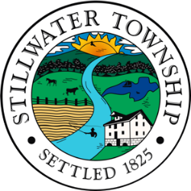

**STILLWATER TOWNSHIP**

**ZONING BOARD OF ADJUSTMENT**

**AGENDA**

**October 23, 2023 - Regular Meeting**

This meeting is in compliance with the Open Public Meetings Act, Public Law 75, Chapter 231, Sections 4 and 13, as advertised by the Annual Notice.

Flag Salute:

Roll Call:

Swearing in of Appointed Board Members:

Approval of Minutes: September 25, 2023

Resolutions:

Completeness: #23-004 Armenante – 941 Emmons Lane, Block 3603, Lot 23

Hearings: - #23-004 - Armenante - 941 Emmons Lane, Block 3603, Lot 23

Bills: **(*May be added if received prior to the hearing date*)**

Correspondence:

Old Business/New Business:

Executive Session:

Open to the Public:

Committee Liaison Report:

Adjournment: