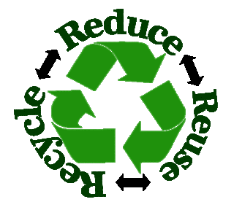
Stillwater Township Recycling and Convenience Center
944 Fairview Lake Road
Hours: Saturday and Sunday 9 a.m.-2 p.m.

The Stillwater Township Recycling and Convenience Center accepts recyclable items and household trash. Trash is weighed at a fee of 15 cents per pound. Larger items i.e. furniture, etc. can also be disposed of at the center for a fee. Please visit the township website for pricing at: www.stillwatertownshipnj.com

Special Wastes including heating oil, kerosene and diesel may also be recycled.
**No gasoline or antifreeze permitted**

Acceptable items for recycling are as follows:

Commingled Dumpster Accepts:
Clean glass bottles and jars, plastic containers #1-7, tin cans, aluminum trays and pie plates, waxed cartons such as milk, juice and ice cream containers.
**No aluminum foil or plastic bags
**Please bring plastic bags to your local grocery store to be recycled**
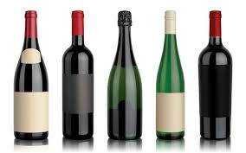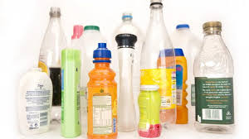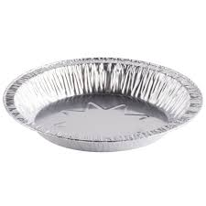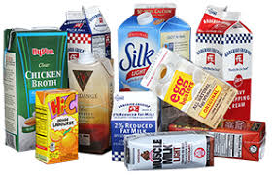

Aluminum Can Dumpster Accepts:
Aluminum cans ONLY. Please keep these separate from commingled items as the township receives money from the recycling of these cans.
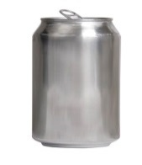
**No Plastic Bags

Mixed Fiber Dumpster Accepts:
Junk mail, magazines, catalogs, office and shredded paper, newspapers, food, cereal and other paperboard, paperback books, hardcover books (Please remove covers and place them in the Corrugated Cardboard Dumpster)
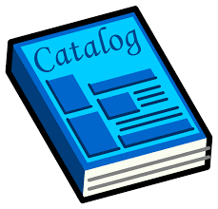

Corrugated Cardboard Dumpster Accepts:
Flattened corrugated boxes and brown bags.
No Styrofoam™ – Please bring to SCMUA for recycling at no charge.

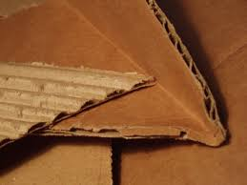

Metal Dumpster Accepts:
Metal appliances, posts, fencing and scrap metal.
**Stillwater Township receives money for all recycled metal**

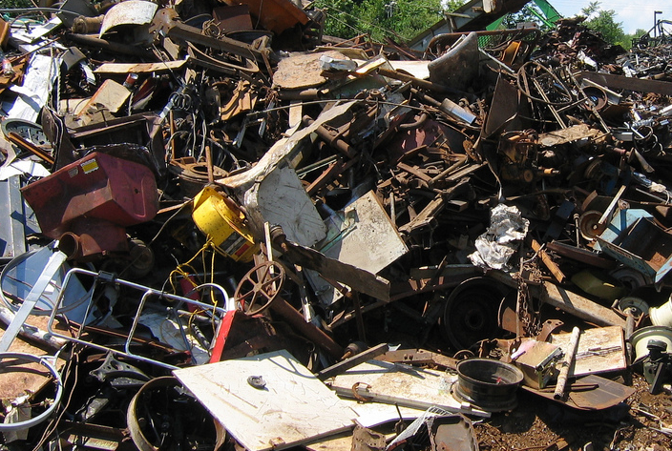
The Stillwater Township Recycling Center holds a FREE tire drop-off weekend and a FREE shredding event during the year. Please visit the township website for further information or contact the office at (973)383-9484.
Additional Information:
Sussex County Municipal Utilities Authority (SCMUA)
34 Route 94
Lafayette, NJ 07848
(973)579-6998

The Sussex County Municipal Utilities Authority offers the following disposal programs at different times throughout the year. Please visit their website at: www.scmua.org

Household Battery Disposal Boat Shrink Wrap

Computers & other E-Waste Document Destruction

Home Medical Waste Household Hazardous Waste

Fluorescent Lamps Rigid Plastic Items

Single Stream Recycling Styrofoam Recycling Program

Presented by the Stillwater Township Environmental Commission – 7/18

