STILLWATER TOWNSHIP
2022 DOG LICENSE APPLICATION
964 STILLWATER ROAD, NEWTON, NJ 07860
NO APPLICATIONS ARE ACCEPTED BEFORE JANUARY 1, 2022
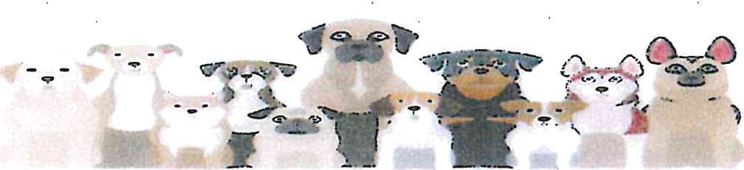
FEES: SPAYED/NEUTERED: $11 PER DOG NON-SPAYED/NEUTERED: $14 PER DOG
*** $5 PER MONTH (PER DOG) LATE FEE WILL BE CHARGED AFTER JANUARY 31, 2022 ***

OWNER'S NAME:

ADDRESS:

PHONE: __________________________________________ E-MAIL:__________________________________

DOG'S NAME: ______________________________ BREED:____________________________ AGE:________________
COLOR:___________________SPAYED/NEUTERED:_____*PLEASE PROVIDE SPAY CERTIFICATE IF LICENSING DOG FOR FIRST TIME

DOG'S NAME: ______________________________ BREED:____________________________ AGE:________________
COLOR:___________________SPAYED/NEUTERED:_____*PLEASE PROVIDE SPAY CERTIFICATE IF LICENSING DOG FOR FIRST TIME

DOG'S NAME: ______________________________ BREED:____________________________ AGE:________________
COLOR:___________________SPAYED/NEUTERED:_____*PLEASE PROVIDE SPAY CERTIFICATE IF LICENSING DOG FOR FIRST TIME

DOG'S NAME: ______________________________ BREED:____________________________ AGE:________________
COLOR:___________________SPAYED/NEUTERED:_____*PLEASE PROVIDE SPAY CERTIFICATE IF LICENSING DOG FOR FIRST TIME

DOG'S NAME: ______________________________ BREED:____________________________ AGE:________________
COLOR:___________________SPAYED/NEUTERED:_____*PLEASE PROVIDE SPAY CERTIFICATE IF LICENSING DOG FOR FIRST TIME

DOG'S NAME: ______________________________ BREED:____________________________ AGE:________________
COLOR:___________________SPAYED/NEUTERED:_____*PLEASE PROVIDE SPAY CERTIFICATE IF LICENSING DOG FOR FIRST TIME

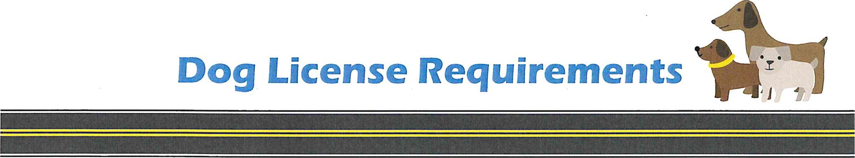
Dear Pet Owner,
To issue a license each year the Rabies Vaccination has to expire After November 1 of the Licensing year. A letter of Vaccine exemption can be issued by your Vets office if your pet qualifies due to age or medical reasons.
There is a $5.00 late fee per month after January 31 until proper documents are submitted to issue a license.
If you have any questions or concerns regarding the requirements please call Stillwater Township Municipal Building 973-383-9484
Or visit The Official Web Site for The State of New Jersey I Dog Licensing (nj.gov) at https://www.nj.gov/nj/community/community/dog licenses.html
Which reads:

Dog Licensing
The owners of all dogs seven months of age or older are required to annually apply to the licensing clerk of the municipality in which he or she resides for a dog license. In order for the license to be issued, the owner must present proof that a licensed veterinarian has vaccinated the dog against rabies and that the duration of immunity from that vaccination extends through at least ten months of the twelve-month licensing period. An exemption to the rabies inoculation requirement shall be granted if the owner presents written certification from a licensed veterinarian that the dog cannot be vaccinated due to a medical condition or course of therapy.
Dog licensing fees are set by municipal ordinance but the maximum that can be charged annually is $21.00. License fees are kept by the municipality and used for animal and rabies control activities. Municipal licensing clerks also collect the following additional fees when the dog is licensed: $1.00 for each dog licensed that is forwarded to the DHSS and placed in the Rabies Trust Fund to support State rabies and animal control programs, $3.00 unneutered dogs that is forwarded to the DHSS, Animal Population Control Pro fund the New Jersey low cost spay and neuter program, and $0.20 for each dog li that is forwarded to the DHSS to defray the costs of operating
Inc. low cost spay and neuter clinic located in Hillside, NJ. These fees erpenacted int"la in 1983.
Respectfully,
Stillwater Township c/o Dog License

